Title of the Experiment
Implementation of Bubble Sort and Insertion/Selection Sort algorithms using C++.

2. Objective and Outcome
- Objective:
  - To study and implement simple sorting algorithms in C++.
  - To understand the differences in sorting techniques and their efficiency.
- Outcome:
  - Students will be able to implement Bubble Sort and Insertion/Selection Sort.
  - Students will learn the working principles of elementary sorting techniques.

3. Software and Tools Used
- Programming Language: C++
- Compiler: g++ / Turbo C++ / MinGW
- IDE: Code::Blocks / Dev-C++ / Visual Studio Code

4. Brief Theory, Algorithm / Flowchart
(a) Bubble Sort
- Theory:
  - Bubble Sort repeatedly compares adjacent elements and swaps them if they are in the wrong order.
  - After each pass, the largest element “bubbles up” to its correct position.
  - Time Complexity: O(n²)
How Bubble Sort Works?
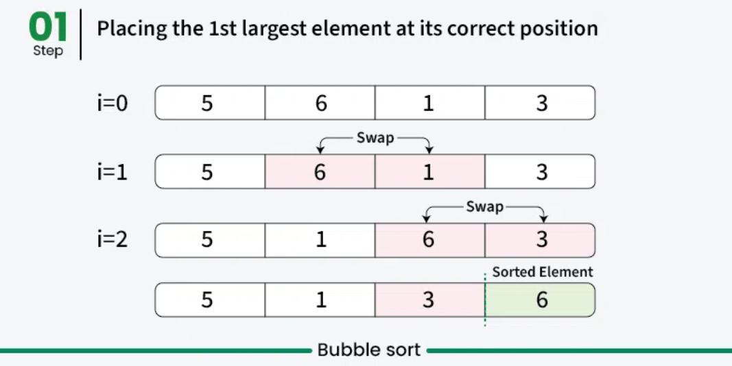
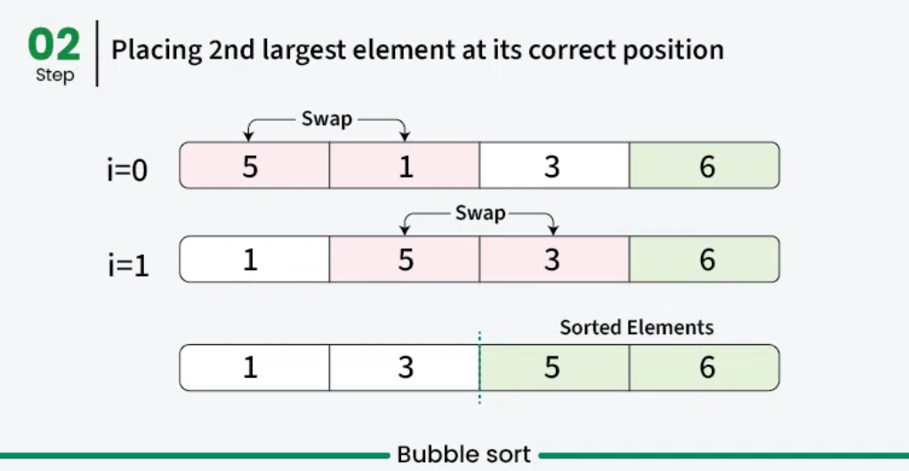
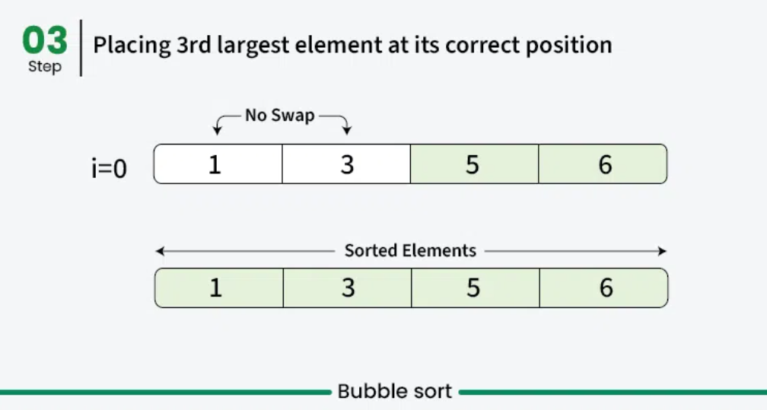
Algorithm:
  - Repeat for i = 0 to n-1.
  - For each pass, compare adjacent elements.
  - Swap if arr[j] > arr[j+1].
  - After each pass, the largest element is placed at the end.

(b) Insertion Sort
- Theory:
Insertion sort is a simple sorting algorithm that works by iteratively inserting each element of an unsorted list into its correct position in a sorted portion of the list. It is like sorting playing cards in your hands. You split the cards into two groups: the sorted cards and the unsorted cards. Then, you pick a card from the unsorted group and put it in the right place in the sorted group.
Key Points :
  - Insertion Sort builds the sorted list one element at a time.
  - It picks the next element and inserts it into its correct position in the already sorted part of the array.
  - Time Complexity: O(n²), Best case O(n).

How It Works?
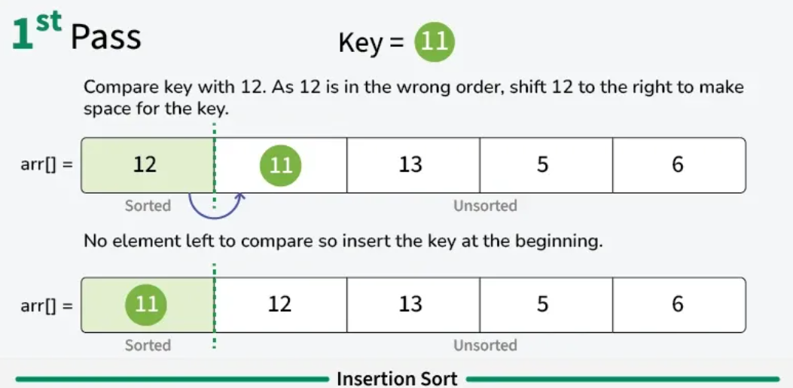
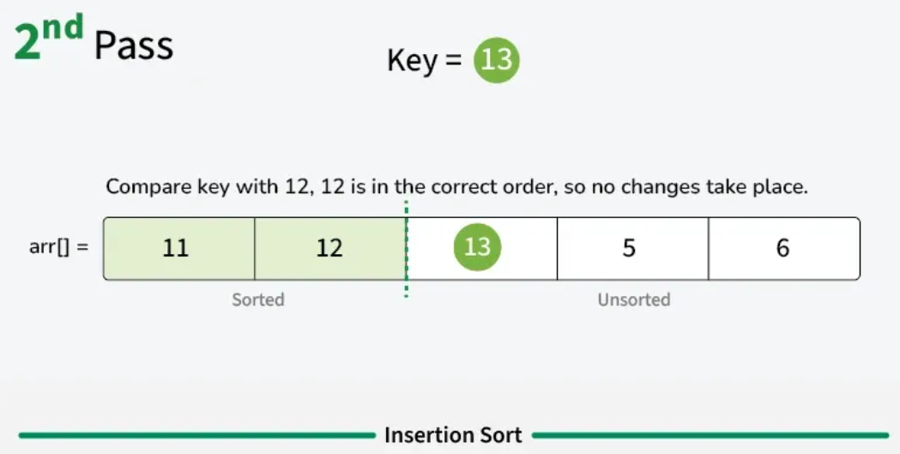
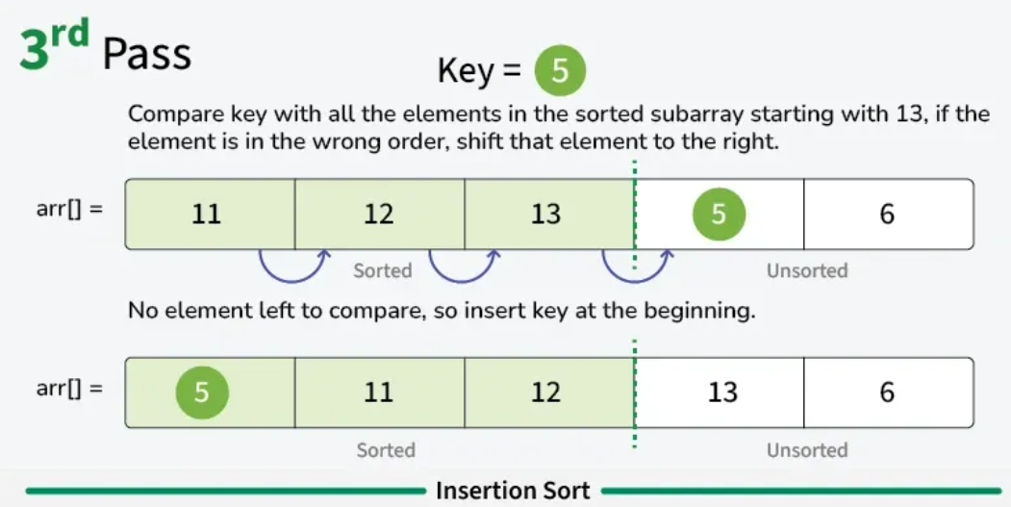
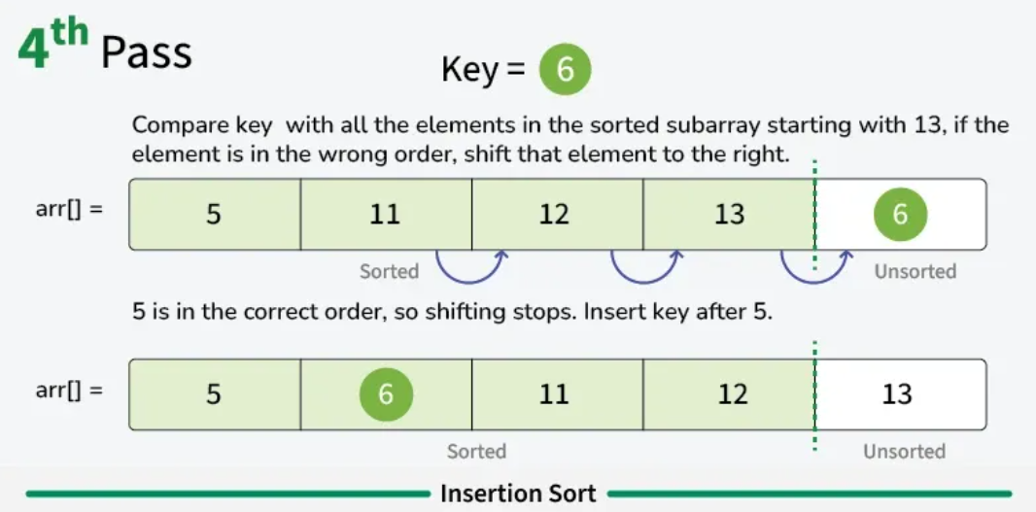
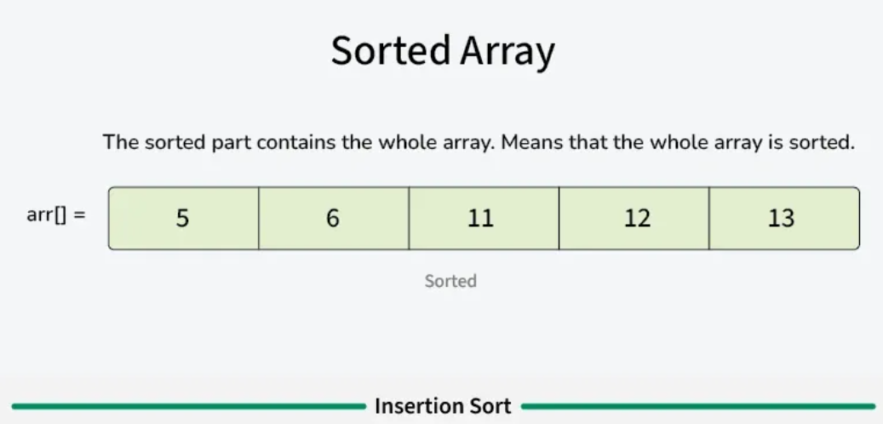
- Algorithm:
  - Start with the second element.
  - Compare it with previous elements.
  - Shift elements greater than the key one position ahead.
  - Insert the key at its correct position.

5. Sample Input/Output – Test Cases
(a) Bubble Sort
Input:
Array = [64, 34, 25, 12, 22, 11]
Output:
Sorted Array = [11, 12, 22, 25, 34, 64]

(b) Insertion Sort
Input:
Array = [12, 11, 13, 5, 6]
Output:
Sorted Array = [5, 6, 11, 12, 13]

6. Conclusions
- Bubble Sort is simple but inefficient for large datasets (O(n²)).
- Insertion Sort works well for small or nearly sorted data, as it performs fewer comparisons.
- Choice of sorting depends on data size, initial order, and efficiency required.

Code : Bubble Sort
#include<iostream>
using namespace std;
// Function to perform Bubble Sort
void bubbleSort(int arr[], int n) {
// Outer loop for number of passes
for(int i = 0; i < n - 1; i++) {
// Inner loop for pair-wise comparison
for(int j = 0; j < n - i - 1; j++) {
// Swap if the current element is greater than the next
if(arr[j] > arr[j + 1]) {
// Swapping using a temporary variable
int temp = arr[j];
arr[j] = arr[j + 1];
arr[j + 1] = temp;
}
}
}
}

// Function to display array elements
void display(int arr[], int n) {
cout << "Sorted array: ";
for(int i = 0; i < n; i++) {
cout << arr[i] << " ";
}
cout << endl;
}

// Main function
int main() {
int arr[100], n;

// Input size of array
cout << "Enter number of elements: ";
cin >> n;

// Input array elements
cout << "Enter " << n << " elements:" << endl;
for(int i = 0; i < n; i++) {
cin >> arr[i];
}

// Call bubble sort function
bubbleSort(arr, n);

// Display sorted array
display(arr, n);

return 0;
}

Code : Insertion Sort:
#include <iostream>
using namespace std;
void insertionSort(int arr[],int n){
for(int i=1;i<n;i++){
int temp = arr[i];
int j= i-1;
while(j>=0 && arr[j]>temp){
arr[j+1] = arr[j];
j-- ;
}
arr[j+1]=temp;
}
}
void display(int arr[],int n){
for(int i=0;i<n;i++){
cout<<arr[i]<<endl;
}
}
int main() {
int arr[]={5,3,8,6,2};
int n=5;
insertionSort(arr,n);
display(arr,n);
return 0;

}

